IE3-CO Lab Session #3: Preparation sheet
Surname, First Name | Group:
Bostandzhieva, Adriana  Stoitsov, Nikolay | 1
This preparation sheet must be filled and uploaded to EMIL by every student before the lab session. Cooperation within the lab team (of 2-3 students) is possible (same solution). However, no cooperation across lab teams.

Question 1:
Develop the flow chart (NSD) for the main program required for task 2.1.3. Make use of following items (add more if necessary or modify them).
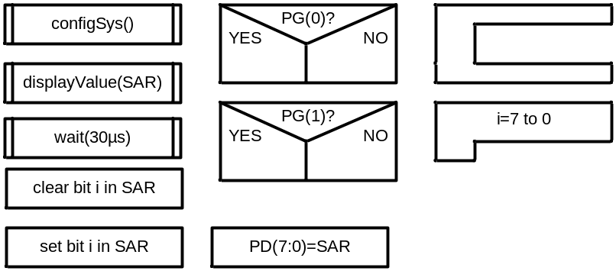
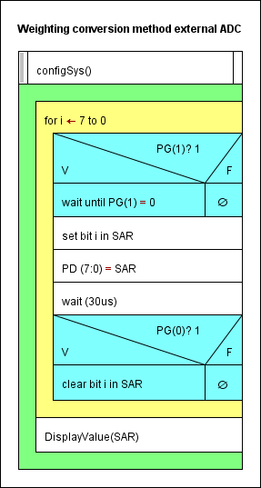

Question 2:
Develop the function configSys() which configures the ports (and timer if you want to realize the time delay by a timer):
void systemConfig(void){

SYSCTL_RCC_R = ((SYSCTL_RCC_R | 0x00000540) & ~0x000002B1);
wait();
// Port Clock Gating Control
SYSCTL_RCGC2_R |= SYSCTL_RCGC2_GPIOD;
wait();

SYSCTL_RCGC2_R = (1 << 3) | (1 << 4) | (1 << 6) | (1 << 8);
wait();

GPIO_PORTD_DEN_R |= 0xFF; // PD (7:0) enabled
GPIO_PORTD_DIR_R |= 0xFF; // PD (7:0) output

GPIO_PORTJ_DEN_R |= 0xFF; // PJ (7:0) enabled
GPIO_PORTJ_DIR_R |= 0xFF; // PJ (7:0) output

GPIO_PORTE_DEN_R |= 0x03; // PE (2:0) enabled
GPIO_PORTE_DIR_R |= 0x03; // PE (2:0) output

GPIO_PORTG_DEN_R |= 0x02; // PG (1:0) enabled
GPIO_PORTG_DIR_R &= ~0x02; // PG (1:0) input

SYSCTL_RCGC1_R |= (1 << 16); //Enable timer0A
wait();
TIMER0_CTL_R &= ~0X0001; //disable timer0A

TIMER0_CFG_R = 0X04; //CONFIGURE timer0 in 16bit mode

TIMER0_TAMR_R |= 0x02; //count down, no match enabled, periodic
TIMER0_TAPR_R |= 3 - 1; //Pre= (0.01*16*10^6/2^16)-1

}

Question 3:
Develop the function displayValue() that receives the successive approximations register value and calculates the voltage in mV. (Full range is 5V, the resolution 10 bit, see assignment sheet for details). Use integer (fix point) operations instead of floating point. Afterwards the function outputs the value in mV on the 7-segment display. For this, the voltage value (mV) has to be decomposed into decimal digits. Write the function in C (incl . conversion to mV and output to display).
void displayValue(unsigned long SAR){

int i;
unsigned short displayDigits[4]; // displayDigits[0] is the most significant digit

for (i = 3; i <= 0; i--){
displayDigits[i] = SAR % 10;
SAR /= 10;
}

GPIO_PORTJ_DATA_R = (displayDigits[2] << 4) | displayDigits[3]; // Assign the two digits on the left to PJ(7:0)
GPIO_PORTE_DATA_R |= 0x01; //Enable display on the right for less significant digits
wait();

GPIO_PORTE_DATA_R &= ~0x01; //Disable the display on the right
GPIO_PORTJ_DATA_R = (displayDigits[0] << 4) | displayDigits[1]; // Assign the two digits on the right to PJ(7:0)
GPIO_PORTE_DATA_R |= 0x02; //Enable display on the right for less significant digits
wait();

GPIO_PORTE_DATA_R &= ~0x02; //Disable the display on the right
}

Question 4:
Write the program for task 2.2.1 which includes the configuration of the ADC and the sampling of channel PE(7).
int main(void){
unsigned long ulData;

SYSCTL_RCC_R = ((SYSCTL_RCC_R | 0x00000540) & ~0x000002B1);
wait();

// activate (clock enable) required modules ADC0 and port PE (AIN0)
SYSCTL_RCGC2_R |= (1 << 4); // PE (AIN0 to AIN2 belong to Port E)
SYSCTL_RCGC0_R |= (1 << 16); // ADC0

// configure AIN0 to AIN2 (=PE(7..5)) as analog inputs
GPIO_PORTE_AFSEL_R |= 0xE0; // PE7..5 alternate function
GPIO_PORTE_DEN_R &= ~0xE0; // PE7..5 disable digital IO
GPIO_PORTE_AMSEL_R |= 0xE0; // PE7..5 enable analog function

// ADC0_SS0 configuration
ADC0_ACTSS_R &= ~0x0F; // disable all 4 sequencers of ADC0
ADC0_SSMUX0_R |= 0x00000102; // sequencer 0, channel AIN2,AIN0,AIN1
ADC0_SSCTL0_R |= 0x00000200; // END2 set, sequence length = 3
ADC0_ACTSS_R |= 0x01; // enable sequencer 0 ADC0

// ADC0_SS0 sampling can be started now
while (1) {
ADC0_PSSI_R |= 0x01; // start ADC0_SS0
while (ADC0_SSFSTAT0_R & (1 << 8)) // wait for FIFO non-empty
;
// read ADC value from FIFO, convert in mV and display
ulData = (unsigned long)ADC0_SSFIFO0_R * 5000UL / 1023;
displayValue(ulData);
}

}

